**Cyberlaw book: Printout labels for the parts to help you navigate it**

Revised 1/28/2025

Book page: <https://johnbandler.com/cyberlawbook/>

Main book resources page: <https://johnbandler.com/cyberlawbook-resources>

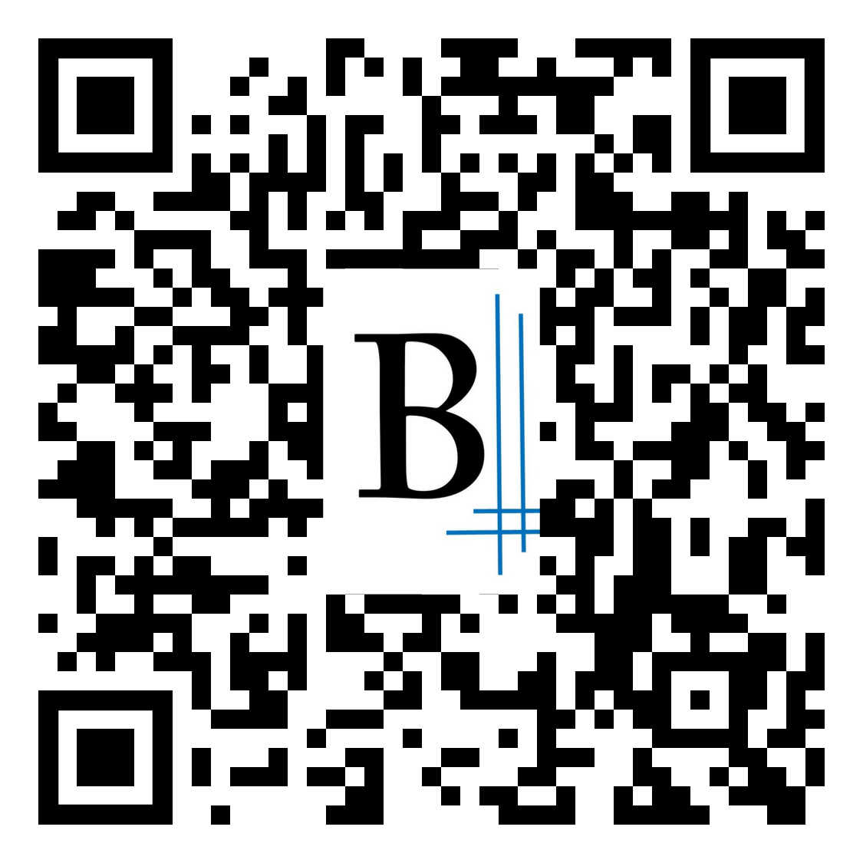Print these out to create tabs for each part

**TOC**

**Contents**

**1**

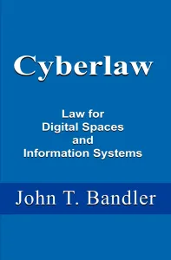 **Mindset**

**2**

**Intro law**

**3**

**Cyber101**

**4**

**Criminal**

**5**

**Civil I**

**6**

**Data Civil II**

**7**

**Internat’l**

**8**

**Speech**

**9**

**Orgs**

**10**

**Appendix**

**GL**

**Glossary**

**IN**

**Index**